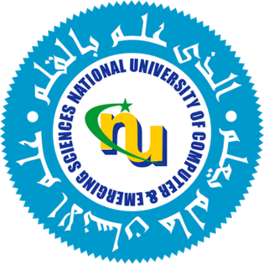
Objective:
Paper Name: Prediction of Literacy Rate of Female Youth in Pakistan Using Time Series Modelling

Authors: Anaum Hamid, Muhammad Rafi

Institution: National University of Computing and Emerging Sciences.

The aim of the study is to predict the year for which we will anticipate 100% literacy rate of female youth in Pakistan.
Introduction:
- Pakistan has a population of approx. 230 million people.
- It is the fifth thickly populated country having higher female proportion
- Pakistan spent 1.7% of its GDP in Education sector for the fiscal year 2021-2022.
- According to UNESCO statistics of 2019, Pakistan’s female literacy youth rate is 65%.
Methodology used:
- Implementation flow diagram:
Data Processing
Identify the ARIMA Model
Estimate the parameters
Generate the best possible model
Forecasting

- More about ARIMA:
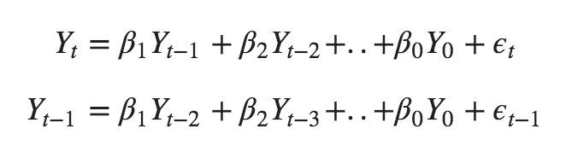
ARIMA, short for ‘Auto Regressive Integrated Moving Average’, explain a given time series based on its own past value (its own lags) and lagged forecast errors, so that equation can be used to forecast future values.
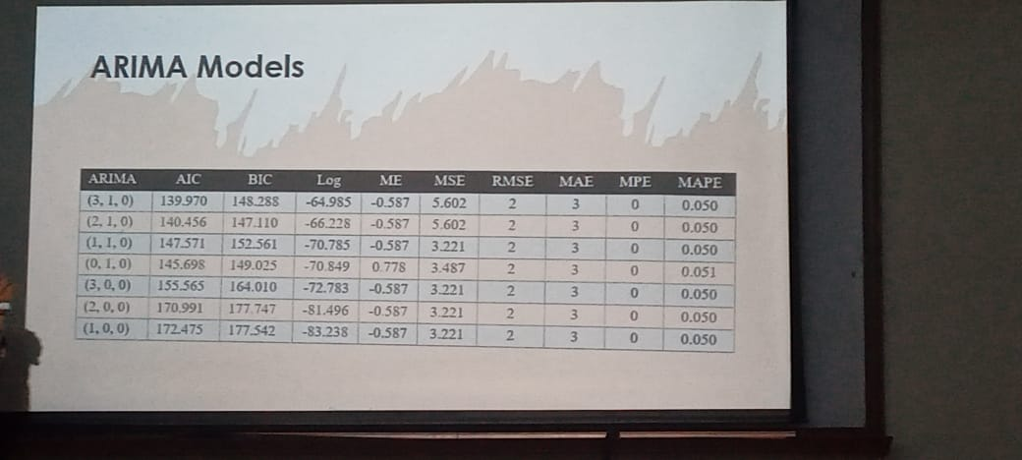
- Conclusion:
Figure 1 ARIMA Model findings
Based on the findings, the goal of having a fully literate female population can be achieved by 2057. Pakistan will accomplish female literacy at 100% by pro-active planning and appropriate government initiatives in the aforementioned year.

